How to replicate or clone the instance

You can't clone an EC2 as such, but you can take a snapshot of it, create an AMI from the snapshot, and then provision a new EC2 instance from that AMI. This is for the system disk (or root disk), additional disks can be snapshotted and then you can choose to "Create volume from snapshot".

<https://docs.aws.amazon.com/AWSEC2/latest/UserGuide/creating-an-ami-ebs.html>

Steps for cloning

1. log in to the AWS Management Console.
2. If required, use the region selector in the top right corner to switch to the region where your instance was launched.
3. Select your instance and then select the “Create Image” option in the “Actions” menu.

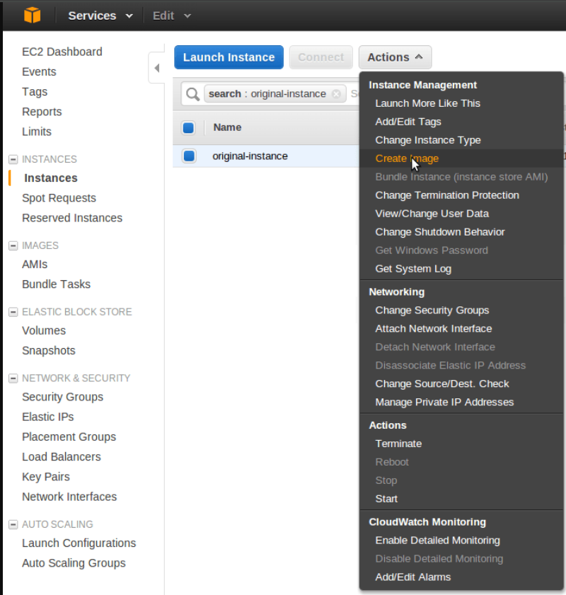

1. Specify the name for the new image and then click the “Create Image” button.

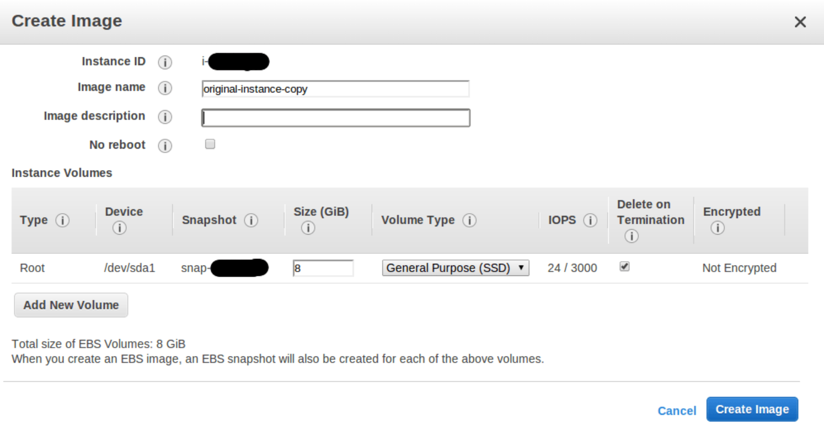

1. Now go to Amazon Machine Images (AMIs) under Images in your left nav. There you will see the newly created instance image. The default status will be Pending. It may take several minutes to an hour to become ready. When the status becomes Available, click and select the AMI from the list.
2. From the top right section click on Launch instance from image Button. Remember to select your current key pair or create a new one.
3. Select the instance type and other details and click the Launch button. The new instance, once launched, will be a clone of the original instance.